Reversing the curse? What are the pathways and pitfalls for innovation in the mining sector in developing countries?
Programme: 09:00 -13:00, Wednesday 7 December 2016
Venue: UNU-MERIT Conference room 0.16-0.17
Boschstraat 24, 6211 AX Maastricht, NL
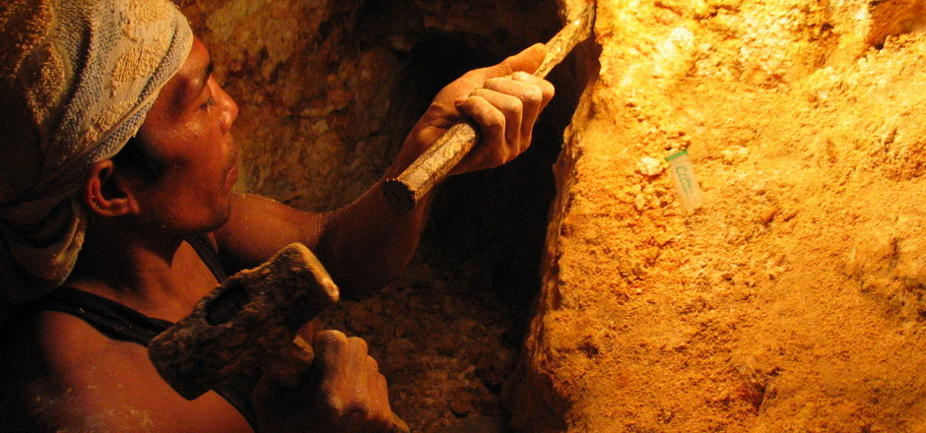
09:00 INTRODUCTION
09:15 SESSION ONE (30 mins. presentation followed by 15 mins. discussion)
- Enhancing linkages and technological capacities in mining: Lessons from South Africa
Prof. David Kaplan, University of Cape Town
- Natural Resources for the Knowledge economy (NR4K) Funds: Experiences from four Latin American countries?
Mr. Fernando Vargas, UNU-MERIT
10:45 COFEE BREAK (30min)
11:15 SESSION TWO (30 mins. presentation followed by 15 mins. discussion)
- Innovation and learning in mining value chains in Latin America
Prof. Carlo Pietrobelli
- Discovering new pathways for productive and technological developing in emerging mining countries
Dr. Michiko Iizuka
12:45 WRAP UP: A SUMMARY FROM EACH SPEAKER AND Q&A
13:00 END

SPEAKERS’ BIOS
Prof. David Kaplan
David Kaplan is a professor at the University of Cape Town, South Africa, where his main focus is on industrial and technology policy. He has worked in government, including the Departments of Science and Technology (DST) and Trade and Industry (DTI). He was Chief Economist at the DTI, 2000-2003, and Chief Economist (part-time) in the Department of Economic Development and Tourism in the Western Cape, 2004-2010. He has also been a member of the National Advisory Council on Innovation (NACI). He conducts policy-oriented research, particularly on how government and business collectively develop policies and strategies that can best enhance development.
Prof. Carlo Pietrobelli
Carlo Pietrobelli is a professor and policy advisor on innovation and industrial development and policy. He is currently Professor of Economics at University Roma Tre, Italy, Professorial Fellow at UNU-MERIT, Maastricht, NL, and Adjunct Professor at Georgetown University, Washington DC, USA. He was Lead Economist at the Inter-American Development Bank, 2009-2016, where he led the preparation of development loans in Latin America and the Caribbean on innovation and industrial policies, and on cluster and value chain programmes, small and medium-sized enterprises and local economic development. His research interests range from development economics to innovation, trade and industry in developing countries.

Dr. Michiko Iizuka
Michiko Iizuka has been a research fellow at UNU-MERIT since 2008, specialising in the economics of innovation and technology. She conducts research into innovation systems and policy in developing countries; innovation in areas of agriculture, natural resources and environmental technology; and the impact of global institutions such as standards and global agreements on local capacity building. She has been the coordinator of the ‘Design and Evaluation of Innovation Policy’ (DEIP) training course for policymakers in developing countries since 2013. She holds a DPhil from the Science Policy Research Unit (SPRU) and an MPhil from the Institute of Development Studies (IDS), both at the University of Sussex, UK.

Mr. Fernando Vargas
Fernando Vargas is a PhD candidate in Economics and Governance at UNU-MERIT. He previously worked in the Competitiveness and Innovation Division at the Inter-American Development Bank. His research focuses on science, technology and innovation policies and private sector development – on which he has advised several Latin American governments. He holds a Master of Science in Applied Economics from the University of Chile.

